

LAB EXPERIMENT RECORD
SET 9: ONLINE LEARNING ANALYSIS

Department | Artificial Intelligence and Data Science
Course Code / Course Name | DSA0601 / Data Handling and Visualization
Name / Register Number | ROHAN P T / 192424112
Date / Day | 03/10/2026

Aim
To analyze online learning activity analysis using the requested visualizations and dashboard views.

Dataset
Online Learning Activity Analysis
Student_ID | Gender | Age | Course | Study_Time | Videos_Watched | Quiz_Score | Login_Date
L01 | Male | 20 | R | 3.5 | 12 | 78 | 2025-01-05
L02 | Female | 22 | R | 4.2 | 15 | 85 | 2025-01-05
L03 | Male | 19 | SQL | 2.0 | 8 | 65 | 2025-02-08
L04 | Female | 21 | R | 5.0 | 18 | 92 | 2025-02-08
L05 | Male | 23 | R | 2.5 | 9 | 70 | 2025-03-12
L06 | Female | 20 | SQL | 4.0 | 14 | 88 | 2025-03-12
Data note: The six rows and dates are supplied in the experiment list. Monthly values aggregate the records by Login_Date.

R Data Setup
Run this setup once before the R programs below. The dataset is defined inline so each record can be copied and run without a separate CSV file.
R data setup
dat <- data.frame(
Student_ID = c("L01", "L02", "L03", "L04", "L05", "L06"),
Gender = c("Male", "Female", "Male", "Female", "Male", "Female"),
Age = c(20, 22, 19, 21, 23, 20),
Course = c("R", "R", "SQL", "R", "R", "SQL"),
Study_Time = c(3.5, 4.2, 2.0, 5.0, 2.5, 4.0),
Videos_Watched = c(12, 15, 8, 18, 9, 14),
Quiz_Score = c(78, 85, 65, 92, 70, 88),
Login_Date = c("2025-01-05", "2025-01-05", "2025-02-08", "2025-02-08", "2025-03-12", "2025-03-12")
)
dat$Login_Date <- as.Date(dat$Login_Date)

PROGRAM 1: Quiz Scores by Distribution and Course
Import the learning dataset. Plot a quiz-score histogram and a score boxplot by course, with titles and labels; interpret performance.
R code
par(mfrow=c(1,2))
hist(dat$Quiz_Score, col="skyblue3", xlab="Quiz score", main="Quiz Score Distribution")
boxplot(Quiz_Score ~ Course, data=dat, col=c("#276B9A","#1D8790"), xlab="Course", ylab="Quiz score", main="Quiz Scores by Course")

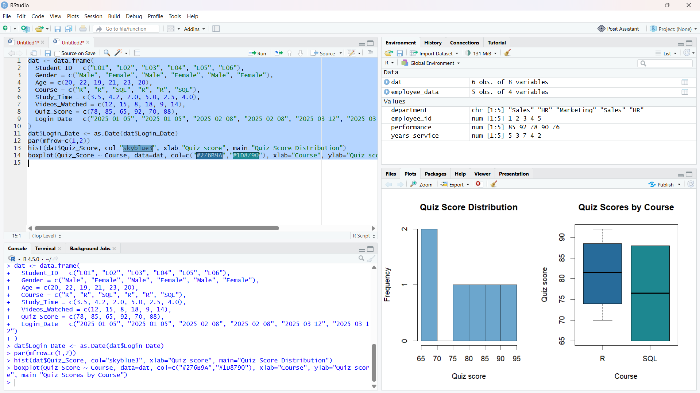
Output 1: Quiz Scores by Distribution and Course

Observation: R has a higher sample mean (81.25) than SQL (76.5), but each course has only a few records.

PROGRAM 2: Learning Time and Quiz Score Bubble Plot
Create a bubble scatter plot of Study_Time versus Quiz_Score, size bubbles by Videos_Watched, and use transparency. Explain the learning pattern.
R code
plot(dat$Study_Time, dat$Quiz_Score, pch=21, bg=adjustcolor("#276B9A", alpha.f=.55), cex=dat$Videos_Watched/6, xlab="Study time (hours)", ylab="Quiz score", main="Study Time vs Quiz Score")
legend("topleft", legend="Bubble size = videos watched", bty="n")

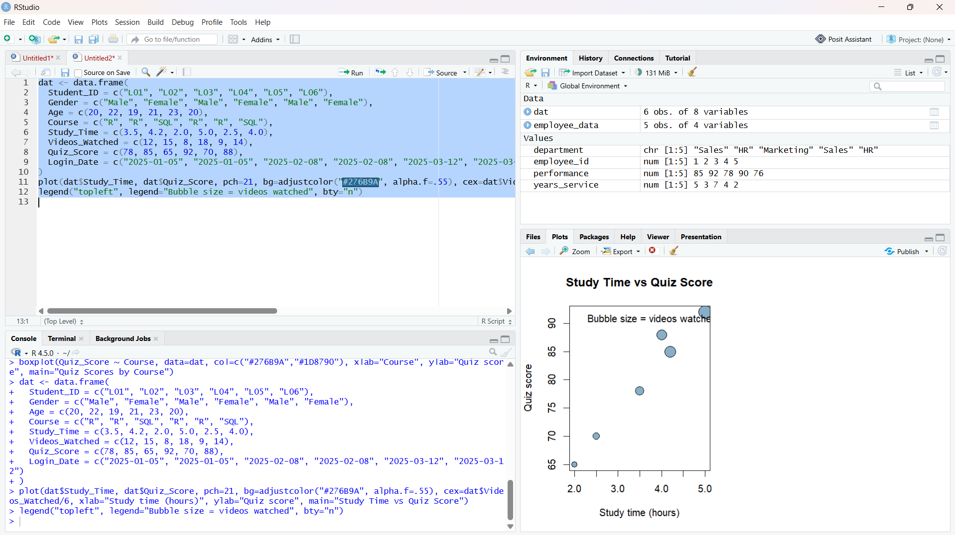
Output 2: Learning Time and Quiz Score Bubble Plot

Observation: The plotted records generally suggest higher quiz scores at longer study times, with some variation; bubble size encodes videos watched.

PROGRAM 3: Monthly Quiz Score Trend
Convert Login_Date to Date, calculate the monthly average quiz score, and plot a smoothed line trend.
R code
dat$Login_Date <- as.Date(dat$Login_Date)
dat$Month <- format(dat$Login_Date, "%Y-%m")
avg <- aggregate(Quiz_Score ~ Month, dat, mean)
avg$Moving_Avg <- stats::filter(avg$Quiz_Score, rep(1/2,2), sides=1)
plot(avg$Quiz_Score, type="o", xaxt="n", xlab="Month", ylab="Average quiz score", main="Monthly Average Quiz Score")
axis(1,1:nrow(avg),avg$Month); lines(avg$Moving_Avg, type="o", col="#E68A36"); legend("topright", c("Monthly average","2-month moving average"), col=c("black","#E68A36"), lty=1, bty="n")

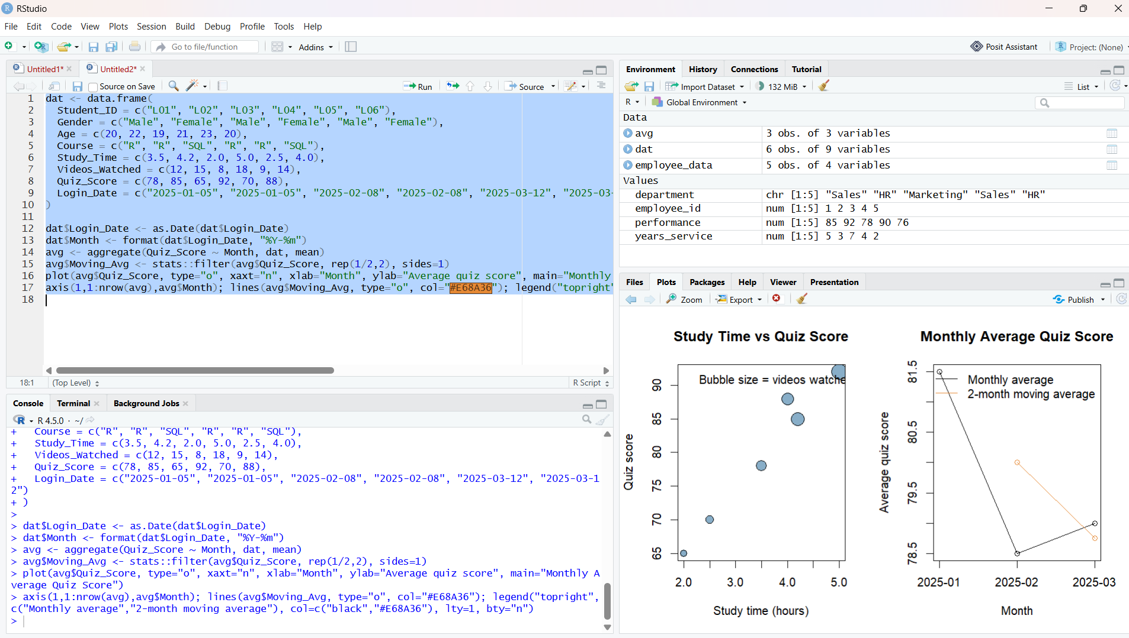

Output 3: Monthly Quiz Score Trend

Observation: The monthly average is highest in January, declines in February, and recovers slightly in March. The two-month moving average smooths the short series.

PROGRAM 4: Online Learning Mini Dashboard
Import Online_Learning_Activity.csv in Tableau, chart average quiz score by course and study time versus score, and add Gender and Course filters.
Tableau build steps
Tableau dashboard build
1. Connect to Online_Learning_Activity.csv or enter the displayed rows.
2. Create a bar chart of AVG(Quiz_Score) by Course.
3. Create a scatter plot with Study_Time on Columns and Quiz_Score on Rows; size by Videos_Watched and color by Gender.
4. Add Gender and Course filters, then combine both sheets on a dashboard.

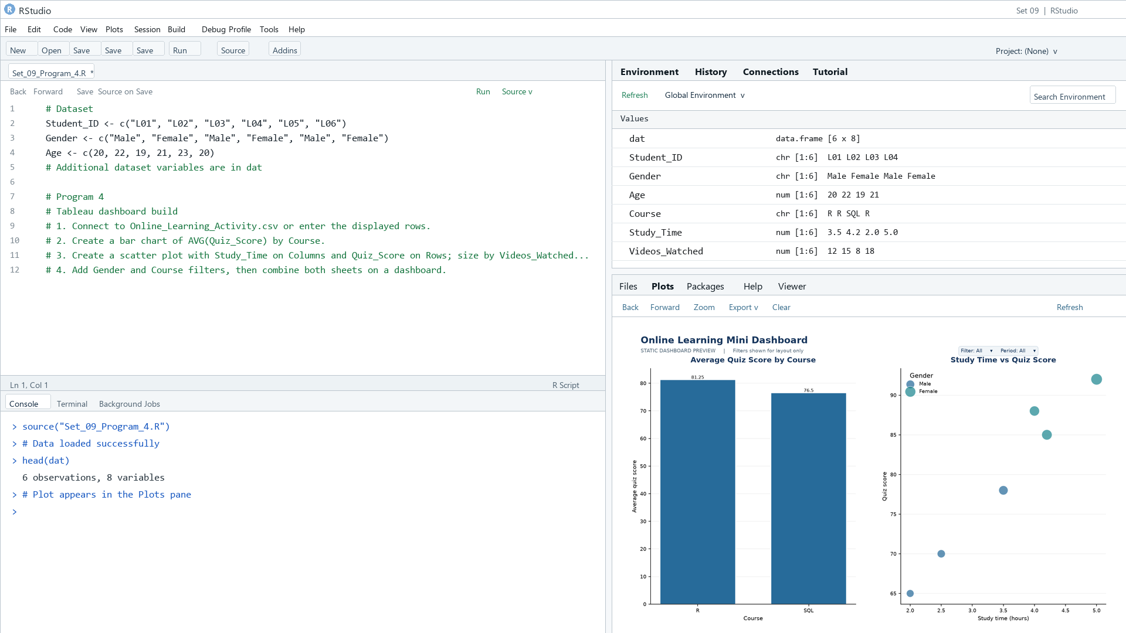
Output 4: Online Learning Mini Dashboard

Observation: The preview compares course averages with individual learning records. Gender and Course filters are specified for the Tableau dashboard.

Procedure
1. Review the dataset table and confirm any illustrative fields noted in the record.
2. Run the R setup block once, then run the requested program code.
3. Compare the output screenshot with the observation and replace illustrative values when actual data is available.
4. For Tableau tasks, connect to the displayed data and follow the dashboard build steps.

Result
The requested charts and dashboard views for Set 9 were prepared from the displayed dataset. Outputs include labels, short observations, and code or dashboard construction steps.

Key Functions Used
plot(), barplot(), hist(), boxplot(), table().

